*建議再自己補充優化
Respiratory tract infection | Upper | Lower
Pathophysiology | Common cold, flu-like illness, pharyngitis, laryngitis | Bronchitis, pneumonia
Cause | Viral | Bacterial
Symptoms | Runny nose, sneezing, nasal blockage, soar throat, cough, sputum  Fever, chills, myalgia  Acute onset, self-limiting | Cough, sputum, Haemoptysis, shortness of breath, pleuritic chest pain  Fever, chills, poor appetite
Risk factor
Test: invasive
Non-invasive | Symptoms / signs  - nasopharyngeal swap: RT-PCR / RAT  - CXR  - Sputum culture
Differentiation | URTI vs pneumonia: symptoms, CXR
Treatment | 1 supportive treatment: IV fluid, oxygen supplement  2 chest physiotherapy  3 specific treatment  - Antiviral, antibiotics for pneumonia (penicillin)
Complications

 | Asthma | COPD
Pathophysiology | Heterogeneous disease  Chronic airway inflammation -> variable airflow limitation / bronchospasm | Emphysema, chronic bronchitis
Cause
Symptoms | Episodic | Cough, sputum, shortness of breath, wheeze, exercise tolerance  Progressive
Risk factor | Weather change, cold air, URTICARIA, air pollution | Smoking, air pollution
Test: invasive
Non-invasive | Lung function test
Differentiation | Clinical course
Treatment | - Inhaler  - drugs: inhaled corticosteroids / long-acting bronchodilators / short-acting bronchodilators
Complications

 | Lung cancer | Obstructive sleep apnoea (OSA)
Pathophysiology | Non-small cell LC, SCLC  Early stage: respectable  Late-stage: metastatic or unresectable | loss of muscle tone in predisposed subjects with narrow upper airway may be obstructed
Cause | Smoking
Symptoms | Thoracic: cough, sputum, Haemoptysis, shortness of breath, wheeze, chest pain  Extra-thoracic: related to metastatic site eg. Neck lumps, bone pain, limb weakness  Para-neoplastic: endocrine, neurological  Constitutional: weight loss | snoring, sleep choking, nocturia, morning headache, daytime sleepiness  - Associations: metabolic syndrome, hypertension, coronary artery disease, cerebrovascular disease
Risk factor |  | obesity, maxillofacial anatomy
Investigation | Pathological:  - Sputum cytology  - Biopsy of tumour site  - Molecular test eg. EGFR  Staging:  - CT thorax / abdomen  - PET-CT | Polysomnography (PSG)
Differentiation
Treatment | 1 SCLC: chemo + RT  2 NSCLC:  - early stage: surgery + adjuvant chemo  - locally advanced: chemo-radio  - metastatic: chemo, targeted therapy, immunotherapy | CPAP
Complications
//

 | Measles 麻疹 | Chicken pox
Pathophysiology | Transmission:  - Aerosol transmission: coughing / sneezing  - Body fluid: nose / mouth  - Highly contagious sharing living place  - Infectivity: 4 days prior rash & 5 days after onset of rash  Incubation period: 7-14 days | - varicella vaccine  - live attenuated vaccine
Cause
Symptoms | High fever, Koplik’s spots, malaise, cough, runny nose  red eyes, maculopapular rash (3rd day)  - trunk then whole body  - 3 Cs: cough, coryza鼻炎, conjunctivitis  Change from red to dark | Nausea, low of appetitive, myalgia肌痛, headache  Low grade fever, oral sores, vesicular rash: body & head -> arms & legs over 12 hours  Vesicle -> blisters -> pustules  - Pneumonia, hepatitis, encephalitis
Risk factor
Investigation |  | - Swap vesicular fluid: direct fluorescent antibody (DFA) / PCR  - blood IgM & IgG
Differentiation
Treatment | Supportive treatment  - NSAID, paracetamol  Prevent: MMR vaccine at 12 months | - IV acyclovir or oral valacyclovir for 5 days  *best within 48 hours  - antihistamine  - calamine lotion
Complications | Diarrhea, pneumonia, otitis media, acute encephalitis, Corneal ulceration | VZIG  Congenital varicella, encephalitis, microcephalic, optic atrophy, damage to spinal cord

 | Zoster | Tuberculosis
Pathophysiology |  | Mycobacterium tuberculosis
Cause
Symptoms | Reactivation of VZV infection  - limited to 1-2 adjacent, unilateral dermatomes  - “grape-like” lesions clustered  - lesion usually heal within 4 weeks | Indolent fever, chills, night sweats, loss of appetite, weight loss , fatigue  Nail clubbing  - pulmonary: chest pain, prolonged coughing with sputum, hemoptysis咳血  - extra-pulmonary: more common in HIV, meningitis, peritonitis, enteric TB  90% latent: asymptomatic
Risk factor
Investigation | Swab vesicular fluid: DFA / PCR  Blood. IgM IgG | - AFB smear / culture (sputum, peritoneal)  - TB-PCR  - adenosine deaminase  - Mantoux test  - IGRA: QuantiFERON Gold
Differentiation |  | Pneumonia, carcinoma, aspergillosis, bronchiectasis
Treatment | IV acyclovir, oral valacyclovir for 7 days  IVIG for immunocompromised  Calamine lotion  Antihistamine  Prevention: zostavax | - HRMZ for 6 months  2nd line: quinolones, PAS, ethionamide,  Organi transplant, high dose steroid
Complications | 1 neurologic: postherpetic neuralgia (PHN), loss of sensation, cranial & motor neurone palsies, hearing loss  2 ophthalmic: visual impairment, ptosis, pain ,facial scar  3 cutaneous: scarring, bacterial, superinfection  4 disseminated: immunocompromised

 | HIV | Malaria瘧疾
Pathophysiology | Trans: blood, semen, vaginal fluid, breast milk  Perinatal transmission
Cause
Symptoms |  | Asymptomatic for 1 week after bitten  Incubation 2 weeks – 1 yr  Fever chills, headache, abdominal pain, diarrhea, cough  Febrile paroxysms co-ordinated with rupture of red cells: 24hr  Hepatosplenomegaly, thrombocytopenia, jaundice
Risk factor
Investigation |  | Mild jaundice, spenomegaly  CBC, LRFT, CXR, blood/urine/stool culture  Blood smear for early malaria diagnosis  - WBC 5000, platelet 100,000
Differentiation |  | Gendue fever, typhoid fever, rickettsioses,
Treatment | Fusion inhibitor: CCR5. gp41  NRTI: zidovudine, lamivudine, tenofovir, stavudine  NNRTI: efavirenz  Integrase inhibitor: raltegrase, doltutegravir | P falciparum  Artemisinin-based  Quinine-based  PV, PM, PO
Complications

1 Hypertension
- Risk factor: family, age, obesity, salt intake
- Complication: Target organ damage, heart failure, stroke, myocardial infarction
2 Atrial fibrillation: increase stroke risk
3 atherogenesis
- Hyperlipideamia, hypertension, smoking, homocysteine
-> endothelial injury / dysfunction
-> circulating platelets adhere to endothelial surface
-> leukocyte adhesion , leukocyte migration
-> endothelial permeability inc.
-> LDL, VLDL, leukocyte accumulation + smooth muscle migration
-> ingestion of oxidised LDL by leukocyte, form foamy macrophage
-> gross appearance of fatty streaking
Smooth muscle proliferation and accumulation extracellular collagen and fatty deposit
4 Unstable angina: Non-Q-wave myocardial infarction, Acute myocardial infarction, Sudden cardiac death
5 Angina : Result from cardiac ischaemia
- Cause: Atherosclerosis, reducing coronary blood flow
Symptoms: Chest pain, dull and pressing
- Relieved by rest after several minutes

 | Stroke | Myocardial infarction (MI)
Pathophysiology | 1 Ischaemic (70%) : due to thrombosis (Atherosclerosis) / embolus, hypotension, poor perfusion (hypotension, arrhythmia )  2 haemorrhagic: intracerebral & subarachnoid haemorrhage
Cause
Symptoms | Paralysis (hemiplegia), numbness, facial palsy, visual filed defect, loss of speech  Subarachnoid haemorrhage:  - sudden onset, neck stiffness, photophobia  - dec. consciousness, bleeding into CSF | - Pain similar to angina, but more intense & prolonged  - Breathlessness due to pulmonary oedema
Risk factor | Hypertension, bleeding tendency (low platelets, leukaemia, haemophilia), drugs (thrombolysis, warfarin)  Vascular abnormalities: aneurysm, tumour
Investigation | CT scan: detect area of damage, look for haemorrhage  Regular neuro-observation  BP, | - ECG: elevation of ST segments  - Rise in cardiac enzyme
Differentiation
Treatment | fluid management IV fluid  Tube feeding in drowsy patients / cannot swallow  Prevent chest infection  Care of urinary tract  Prevent pressure sores  Physio, speech therapy, rehab | 1 pain relief (morphine, nitrates)  2 heart failure (diuretics)  3 thrombolysis: streptokinase, recombinant tissue plasminogen activator (rt-PA)  - Degrade thrombus, reestablish coronary blood flow  - Reduce myocardial damage  - XXX* patients prone to bleed  4 aspirin  Long term  1 anti-platelet agent  2 angiotensin-converting enzyme inhibitor (ACEI)  3 beta-blocker  4 statin
Complications | Cerebrovascular disease: haemorrhage into the lateral ventricle of the brain -> hemiplegia, death

 | Stroke | Migraine headache
Pathophysiology | Ischemia / hemorrhagic
Cause |  | Brian haemorrhage, infections eg meningitis, space occupying lesion
Symptoms | Sudden onset | Recurrent attacks, 5-60min, complete reversible  Often unilateral  Nausea, photophobia, phnophonbia
Risk factor | Premorbid hypertension, hyperlipidemia, chronic smoker
Investigation
Differentiation
Treatment | IV thrombolysis: streptokinase, recombinant tissue plasminogen activator (rt-PA)  Mechanical thrombectomy
Complications

 | Neuropathy | Tremor
Pathophysiology | Polyneuropathy, mononeuropathy, mononeuropathy pmultiplex
Cause | Renal failure, critical illness, hypothyroidism, vitamin deficiencies  Autoimmune, paraneoplastic  Toxic: alcohol, chemotherapy  Hereditary
Symptoms | Asymmetry, non-length dependence, motor predominance, acute onset, severe or rapidly progressive  1 Upper extremity PNS: C5-T1 nerve roots  - compression eg. Radiculopathym , carpel tunnel syndrome (risk factor: obesity, diabetes, hypothyroidism)  - inflammatory: herpes zoster  2 lower extremity PNS:  - compression eg. Tarsal tunnel syndrome  - inflammatory: herpes zoster  3. Facial weakness  4. Ramsay Hunt syndrome | Involuntary, rhythmic, oscillatory movement  Rest tremor  Eg. Parkinson’s disease, atypical P disease  Action: occurs with voluntary muscle contraction  - Enhanced physiologic tremor: drugs, caffeine, thyrotoxicosis, anxiety  Eg. Kinetic, postural, isometric  Blood test
Risk factor
Investigation | History, PE, blood tests, nerve conduction studies / electromyography  Imaging eg MRI spine
Differentiation
Treatment
Complications

 | Vertigo 眩暈 | Vasovagal syncope 血管迷走神經性昏厥
Pathophysiology | Dysfunction of labyrinth, vestibular nerve, central vestibular structure
Cause
Symptoms | Illusory movement  Central: brain stem symptoms  Eg. Balance prob, inability to cough, nausea, vomiting  Peripheral: tinnitus, hearing impairment | Self-limiting systemic hypotension: bradycardia, peripheral vasodilation  - preceded: fatigue, nausea, weakness, sensation of impending faint  - precipitated with prolonged standing, heat exposure, sudden painful, traumatic experience  -signs of autonomic hyperactivity eg. Pallor, diaphoresis, nausea, sweating  - often recurrent, affect young ppl
Risk factor
Investigation | 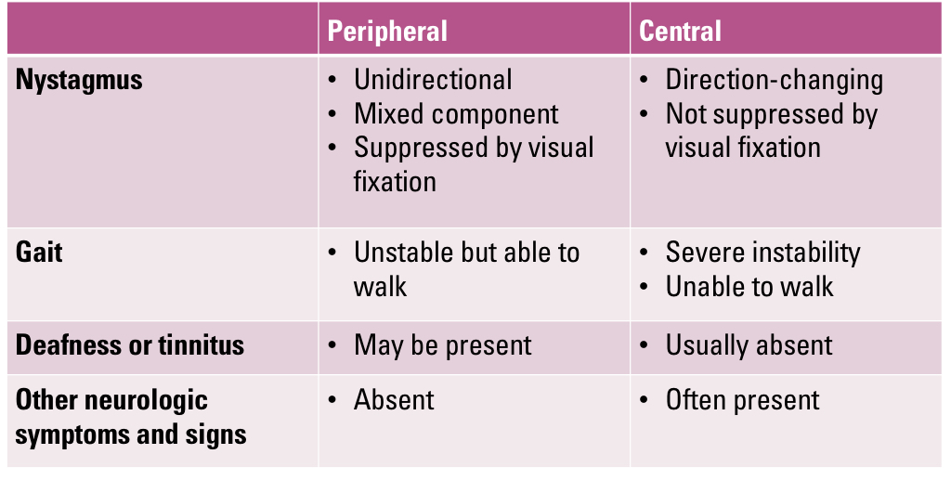 | Neuroimaing  Nerve conduction tests  Electroencephalography
Differentiation
Treatment
Complications

 | Seizure 癲癎 | Syncope 暈厥
Pathophysiology | - Seizure: result of systemic or brain insult, including metabolic derangements, drug or alcohol withdrawal, encephalitis, head injury  - epilepsy: at least 2 unprovoked seizure occurring more than 24 hours apart /  1 unprovoked seizure with an expected inc. risk for recurrence  Eg. Structural lesion such as stroke, history of brain injury
Cause | Seizure: drug/alcohol withdrawal, injury  Epilepsy: brain tumour, degeneration of Brain, stroke | 1 reduced cardiac output: arrhythmia, outflow tract obstruction  2 hypotension: reduced IV volume, drugs  3 reflex syncope: neural reflexes HR/ BP inappropriately  Inadequate cerebral blood flow  Results from abrupt blood pressure drop
Symptoms | Sudden change in behaviour caused by electrical hypersynchronization of neural network  No preceding symptoms  Twitching of 4 limbs | Preceded: nausea, sweeting, light-headedness  Loss of consciousness for a few seconds  Transient, self-limiting
Risk factor
Investigation | Neuroimaing  Nerve conduction tests  Electroencephalography | Neuroimaing  Nerve conduction tests  Electroencephalography
Differentiation | 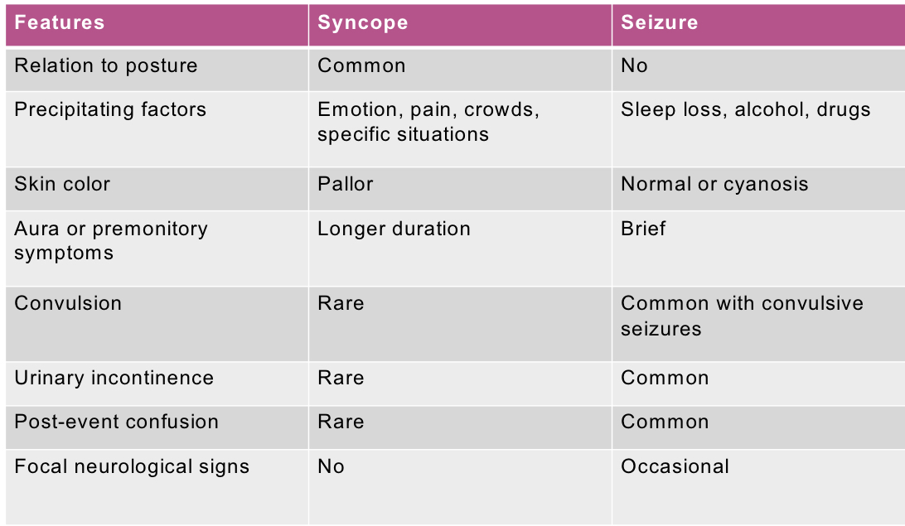
Treatment
Complications

Pathophysiology
Cause
Symptoms
Risk factor
Investigation
Differentiation
Treatment
Complications

